2021.07.08 BASIC의 docker git 작업 https://github.com/mitmedialab/Basic

* 도커 바이너리 설치

<https://download.docker.com/linux/static/stable/x86_64/>

여기 들어가서 18.09.09 다운로드 받음 git 날짜 맞춰서

* 압축풀기dock

tar xvzf docker-18.09.9.tgz

* 참고: 환경변수 찾는 명령어 사용예시) whereis ls <https://ggodong.tistory.com/183>
* 도커 이하 바이너리(Docker/*)를 usr/bin으로 옮겼음 sudo cp ~/Downloads/docker/* /usr/bin
* 도커 데몬 실행

<https://velog.io/@weekbelt/%EB%8F%84%EC%BB%A4%EB%8D%B0%EB%AA%ACDocker-Daemon>

* 테스트

gianthips@ubuntu:~$ sudo docker run hello-world

Unable to find image 'hello-world:latest' locally

latest: Pulling from library/hello-world

b8dfde127a29: Pull complete

Digest: sha256:9f6ad537c5132bcce57f7a0a20e317228d382c3cd61edae14650eec68b2b345c

Status: Downloaded newer image for hello-world:latest

INFO[2021-07-08T07:47:22.590035546-07:00] shim containerd-shim started address="/containerd-shim/moby/5bd9bb57f073b01629b561e628dc15f0a55cf62add7eed97e8aef08d0d9f4178/shim.sock" debug=false pid=6465

Hello from Docker!

This message shows that your installation appears to be working correctly.

To generate this message, Docker took the following steps:

1. The Docker client contacted the Docker daemon.

2. The Docker daemon pulled the "hello-world" image from the Docker Hub.

(amd64)

3. The Docker daemon created a new container from that image which runs the

executable that produces the output you are currently reading.

4. The Docker daemon streamed that output to the Docker client, which sent it

to your terminal.

To try something more ambitious, you can run an Ubuntu container with:

$ docker run -it ubuntu bash

Share images, automate workflows, and more with a free Docker ID:

https://hub.docker.com/

For more examples and ideas, visit:

https://docs.docker.com/get-started/

INFO[2021-07-08T07:47:22.939989866-07:00] shim reaped id=5bd9bb57f073b01629b561e628dc15f0a55cf62add7eed97e8aef08d0d9f4178

INFO[2021-07-08T07:47:22.954575294-07:00] ignoring event module=libcontainerd namespace=moby topic=/tasks/delete type="*events.TaskDelete"

gianthips@ubuntu:~$

* 도커 버전 확인 docker -v
* 권한 부여

gianthips@ubuntu:~$ su

Password:

su: Authentication failure

sudo passwd root

* 그룹추가

Sudo groupadd docker

<https://github.com/moby/moby/pull/21032>

sudo usermod -aG docker $USER

https://dhananjay4058.medium.com/what-does-sudo-usermod-a-g-group-user-do-on-linux-b1ab7ffbba9c

https://gntpapa.tistory.com/entry/8-docker-%EC%9D%BC%EB%B0%98-%EC%82%AC%EC%9A%A9%EC%9E%90%EA%B0%80-docker-%EC%8B%A4%ED%96%89-%EB%B0%A9%EB%B2%95

sudo usermod -aG docker $USER

확인 cat /etc/group

* Sudo apt install git
* git clone <https://github.com/mitmedialab/Basic.git>
* sudo apt install docker-compose
* 이 부분 docker-compose 자체가 안되어서 이상했는데, 갑자기 돌기 시작. 리부트가 필요했던듯.
* docker-compose up
  + <https://www.44bits.io/ko/post/almost-perfect-development-environment-with-docker-and-docker-compose> 참고
* 돌렸는데, 워닝 많이 떴고, 결국 에러.

npm ERR! code 1

ERROR: Service 'bootstrap' failed to build: The command '/bin/sh -c npm install npm@latest -g' returned a non-zero code: 1

* 연욱이 말대로 코드를 수정하기 위해 vim 설치

<https://gabii.tistory.com/entry/Ubuntu-vim-%EC%84%A4%EC%B9%98-%EB%B0%8F-%EC%84%A4%EC%A0%95>

* 코드 수정
  + ~/Basic/docker-geth-network-master/monitored-geth-client
  + vim Dockerfile, 복붙
* Dockerfile

** 잠깐 전체 프로그램에 대한 공부

Nodejs: <https://araikuma.tistory.com/452>

Netstats:

Bootstrap

__________________________________________________________정상적으로 돌아가는 듯함

2021.07.09 cityscope git 작업

- <https://cityscope.media.mit.edu/>

- <https://github.com/CityScope/CS_Simulation_GAMA>

- <https://gama-platform.github.io/wiki/Installation>

* Open JDK는 안 좋고 가급적 Oracle JDK 8 를 설치하라고 함.

https://lindarex.github.io/concepts/difference-between-oraclejdk-openjdk/

* 그냥 Gama with JDK를 쓰는게 좋을 듯.
* Gama with JDK 깔고
* <https://github.com/CityScope/CS_Simulation_GAMA> 여기에서 git clone 한다음
* right click on User Models->Import->GAMA Project..
* Select CS_CityScope_GAMA in the CS_Simulation_GAMA folder that you have clone
* Cityscope 프로젝트를 별도로 구현해야 하나 싶었는데, 아닌 듯. .Basic/AgentBased_Simulator/models에 기존 cityscope 코드들 거의 다 있음.
* 지금 dockerfile 다시 살펴보는 중. 참고로 익혀둘 사항

Eth-net-intelligence-ap: eth-netstats

<https://eth.wiki/en/concepts/network-status>

<http://blockchaindev.kr/models/content/98>

* 다시 Project Description 읽어보는 중
* Docker-compse scale eth=3 했는데 잘 됨

gianthips@ubuntu:~/Basic/docker-geth-network-master/monitored-geth-client$ docker-compose scale eth=3

WARNING: The scale command is deprecated. Use the up command with the --scale flag instead.

Starting dockergethnetworkmaster_eth_1 ...

Starting dockergethnetworkmaster_eth_1 ... done

Creating dockergethnetworkmaster_eth_2 ...

Creating dockergethnetworkmaster_eth_3 ...

Creating dockergethnetworkmaster_eth_2 ... done

Creating dockergethnetworkmaster_eth_3 ... done

* Basic 설명에 이런 글귀 있음.

You need to have at least one node mining in the simulation. To get attached to the geth JavaScript console on the node you can run the following

* Geth는 go-ethereum이고 Dockerfile에 이미 자동 설치하게 되어있는 듯.

docker exec -it docker-geth-network-master_eth_1 geth attach ipc://root/.ethereum/devchain/geth.ipc

* 이대로 넣으면 안된다

docker exec -it dockergethnetworkmaster_eth_1 geth attach ipc://root/.ethereum/devchain/geth.ipc

* 근데
* Fatal: Unable to attach to remote geth: dial unix //root/.ethereum/devchain/geth.ipc: connect: connection refused
* 참고가 될 수 있을까?

<https://ethereum.stackexchange.com/questions/52464/fatal-unable-to-attach-to-remote-geth-dial-unix-ethereum-geth-ipc-connect>

* Docker 명령어 자체를 살펴보자

<http://pyrasis.com/book/DockerForTheReallyImpatient/Chapter20/08>

docker exec

-it: 옵션. https://bluese05.tistory.com/21

* -i: 표준 입력(stdin)을 활성화하며 컨테이너와 연결(attach)되어 있지 않더라도 표준 입력을 유지한다.

* -t: TTY모두(pseudo-TTY)를 사용한다.

* dockergethnetworkmaster_eth_1 컨테이너 이름
* geth attach ipc://root/.ethereum/devchain/geth.ipc
  + docker exec -it dockergethnetworkmaster_eth_1 geth version 하면 뭐가 나옴
  + 근데 geth version 그냥 치면 안나옴
  + 컨테이너 상에는 geth가 돌아가는 모양
  + 근데 글로벌에는 Geth는 안돌아간다
* 그럼 ipc://root/.ethereum/devchain/geth.ipc 가 문제인가
  + Find geth.ipc 하니까 없다네
  + 참고가 될 수 있을까?

<https://ethereum.stackexchange.com/questions/10674/cannot-attach-to-geth-node-running-inside-container>

<https://ethereum.stackexchange.com/questions/1492/when-is-the-geth-ipc-file-produced>

* + docker exec -it dockergethnetworkmaster_eth_1 geth 하면 geth는 돌아간다.
  + docker exec -it dockergethnetworkmaster_eth_1 geth attach ipc://root/.ethereum/devchain/geth.ipc 이렇게 하면 안 돌아간다.
  + <https://stackoverflow.com/questions/59942682/what-is-the-difference-between-these-scripts-for-geth-attach>

* 참고 docker exec -it ethereum-docker_eth_1 geth attach ipc://root/.ethereum/devchain/geth.ipc You are running geth attach directly in your container using ipc. IPC is a way to communicate between process using file (i may be wrong on this point)

2021.07.10 geth javaconsole 관련

* + 글로벌로 geth 를 설치하면 달라질까 싶어서 Sudo snap install geth 했음
  + 도커의 geth version은 1.8.17인데

글로벌의 geth version은 1.9.5이네

* + 그래서 그냥 삭제를 해야겠음 snap remove geth
  + <https://geth.ethereum.org/docs/install-and-build/installing-geth>

우선 이전에 go를 설치하고, 환경변수 업데이트를 했다. /etc/profile에다가.

go get -d github.com/ethereum/go-ethereum@v1.8.17

그리고 리붓

* + 그리고 docker exec -it dockergethnetworkmaster_eth_1 geth attach ipc://root/.ethereum/devchain/geth.ipc 하니 돌아간다.

gianthips@ubuntu:~/Basic/docker-geth-network-master$ docker exec -it dockergethnetworkmaster_eth_1 geth attach ipc://root/.ethereum/devchain/geth.ipc

Welcome to the Geth JavaScript console!

instance: Geth/v1.8.17-unstable/linux-amd64/go1.10.4

coinbase: 0x007ccffb7916f37f7aeef05e8096ecfbe55afc2f

at block: 0 (Thu, 01 Jan 1970 00:00:00 UTC)

datadir: /root/.ethereum/devchain

modules: admin:1.0 debug:1.0 eth:1.0 ethash:1.0 miner:1.0 net:1.0 personal:1.0 rpc:1.0 txpool:1.0 web3:1.0

* + Go가 설치가 안되어있던게 문제였던가 아니면 리붓이 문제였던듯.
  + Geth는 도커랑 버전 맞추어서 이제서야 깐다.

go get -d [github.com/ethereum/go-ethereum@v1.8.17](mailto:github.com/ethereum/go-ethereum@v1.8.17)

go install [github.com/ethereum/go-ethereum/cmd/geth@v1.8.17](mailto:github.com/ethereum/go-ethereum/cmd/geth@v1.8.17)

명령 입력하면 돌아는 가는데 제대로 안깔린듯. geth 치는데 안나오네. 글로벌이니 그냥 넘어가자

* docker exec -it dockergethnetworkmaster_eth_1 geth attach ipc://root/.ethereum/devchain/geth.ipc 실행하고 miner.start() 해본다.
  + Miner.start() 하면 null이 나온다.
  + Eth.mining 쳐보면 true가 된다.
  + Eth.hashrate하면 0이 나오네 이건 왜 그러지? <https://dejavuqa.tistory.com/234>

https://ethereum.stackexchange.com/questions/51220/cpu-mining-on-testnet-using-geth-on-ubuntu-eth-hashrate-0

* + Eth.blockNumber 때려보면 숫자는 계속 증가하고 있음.
* Geth javaconsole에서 Hashrate = 0의 문제
  + 잠깐 스탑
* Sudo apt install pythonpy로 py하고 Basic readme의 밑부분 해보자
  + 이건 왜?

gianthips@ubuntu:~/Basic/PythonInterface$ py connection_interface.py

Traceback (most recent call last):

File "/usr/bin/py", line 167, in <module>

result = eval(args.expression)

File "<string>", line 1, in <module>

connection_interface.py

NameError: name 'connection_interface' is not defined

* + Python connection_interface.py 로 실행(설명창에는 그냥 환경변수 설정해놓은듯)

실행은 되네

* Docker-compose up을 하니까 뭔가 마이닝 하는 그림이 뜨기 시작했음

근데 뭔가 컨테이너 2, 3은 끈다는 말이 나왔던듯

* 강제 종료 하고

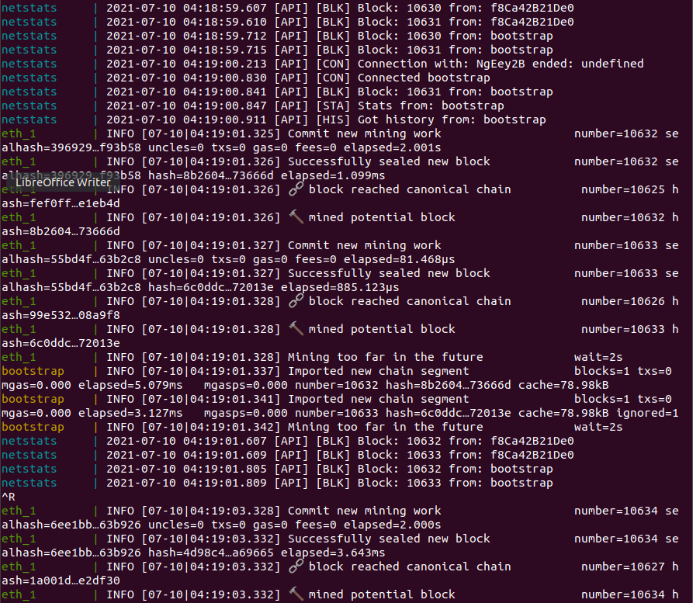

* 다시 해보자 리붓부터

___________________________

* 어떻게 해야 돌아가려나
* Case1
  + gianthips@ubuntu:~/Basic/docker-geth-network-master$ docker-compose scale eth=3

WARNING: The scale command is deprecated. Use the up command with the --scale flag instead.

Desired container number already achieved

* + docker-compose up 하니까 컨테이너 2개를 꺼버리네
* **Case2**
  + **Docker-compose up을 백그라운드 프로세스로 돌리기**
  + [**https://runnable.com/docker/introduction-to-docker-compose**](https://runnable.com/docker/introduction-to-docker-compose) **여기보면 백그라운드로 돌리는거 있음**

**gianthips@ubuntu:~/Basic/docker-geth-network-master$ docker-compose up -d**

**Starting netstats ...**

**Starting netstats ... done**

**Starting bootstrap ...**

**Starting bootstrap ... done**

**Starting dockergethnetworkmaster_eth_1 ...**

**Starting dockergethnetworkmaster_eth_1 ... done**

* + **gianthips@ubuntu:~/Basic/docker-geth-network-master$ docker-compose scale eth=3WARNING: The scale command is deprecated. Use the up command with the --scale flag instead.**

**Starting dockergethnetworkmaster_eth_1 ... done**

**Creating dockergethnetworkmaster_eth_2 ...**

**Creating dockergethnetworkmaster_eth_3 ...**

**Creating dockergethnetworkmaster_eth_2 ... done**

**Creating dockergethnetworkmaster_eth_3 ... done**

* + **gianthips@ubuntu:~/Basic/docker-geth-network-master$ docker-compose ps**

**Name Command State Ports**

**-------------------------------------------------------------------------------**

**bootstrap /root/start.sh Up 0.0.0.0:30303->30303/**

**--datadir=~ ... tcp, 0.0.0.0:30303->3**

**0303/udp, 0.0.0.0:855**

**5->8555/tcp**

**dockergethnetworkmaste /root/start.sh Up**

**r_eth_1 --datadir=~ ...**

**dockergethnetworkmaste /root/start.sh Up**

**r_eth_2 --datadir=~ ...**

**dockergethnetworkmaste /root/start.sh Up**

**r_eth_3 --datadir=~ ...**

**netstats docker-entrypoint.sh Up 0.0.0.0:3000->3000/tc**

**npm start p**

* + **순서를 이렇게 가니 컨테이너가 두개 더 생긴듯 하다**
  + **gianthips@ubuntu:~/Basic/docker-geth-network-master$ docker exec -it dockergethnetworkmaster_eth_1 geth attach ipc://root/.ethereum/devchain/geth.ipc**

**Welcome to the Geth JavaScript console!**

**instance: Geth/v1.8.17-unstable/linux-amd64/go1.10.4**

**coinbase: 0x007ccffb7916f37f7aeef05e8096ecfbe55afc2f**

**at block: 0 (Thu, 01 Jan 1970 00:00:00 UTC)**

**datadir: /root/.ethereum/devchain**

**modules: admin:1.0 debug:1.0 eth:1.0 ethash:1.0 miner:1.0 net:1.0 personal:1.0 rpc:1.0 txpool:1.0 web3:1.0**

* + **돌기 시작**
  + **> miner.start()**

**null**

**> web3.eth.mining**

**True**

**> exit**

* **이거부터 확인해보자**

**To access the Netstats Web UI:**

**open http://$(docker-machine ip default):3000**

* + **도움이 되려나?**

[**https://www.freecodecamp.org/news/how-to-get-a-docker-container-ip-address-explained-with-examples/**](https://www.freecodecamp.org/news/how-to-get-a-docker-container-ip-address-explained-with-examples/)

* + **gianthips@ubuntu:~$ docker ps --format "table {{.ID}} {{.Status}} {{.Names}}"**

**CONTAINER ID STATUS NAMES**

**1f86b87f7a85 Up 44 minutes dockergethnetworkmaster_eth_3**

**4a5a5955b7c7 Up 44 minutes dockergethnetworkmaster_eth_2**

**f8ca42b21de0 Up 46 minutes dockergethnetworkmaster_eth_1**

**b2bdb3faee92 Up 46 minutes bootstrap**

**08ac4b12afda Up 46 minutes netstats**

* + **gianthips@ubuntu:~$ docker network ls**

**NETWORK ID NAME DRIVER SCOPE**

**b4d6c2f382b3 bridge bridge local**

**91554af379e8 dockergethnetworkmaster_default bridge local**

**c41cc4b31829 host host local**

**79dfaafe48f0 none null local**

* + **gianthips@ubuntu:~$ docker inspect -f '{{range.NetworkSetiings.Networks}}{{.IPAddress}}{{end}}' f8ca42b21de0**

**Template parsing error: template: :1:23: executing "" at <.NetworkSetiings.Networks>: map has no entry for key "NetworkSetiings"**

* + **흠…**
  + **일단 건너가자 파이썬 백그라운드 실행**

**gianthips@ubuntu:~/Basic/PythonInterface$ python connection_interface.py&**

**[1] 86429**

**gianthips@ubuntu:~/Basic/PythonInterface$ Socket created**

**Socket bind complete**

**Socket now listening**

* 이제 해야할 일?
  + GAMA 시뮬레이션이랑 연결. 근데 지금 컨테이너 수를 3개로 했으니 AV 수도 3개가 되어야 한다.
  + 이더리움 상황? 확인할 수 있도록 Netstats에 접속해야 한다. 근데 도커머신 ip를 찾다가 포기.

2021.07.12 도커머신 주소

* + 도커와 도커머신은 서로 다르구나

<https://www.youtube.com/watch?v=S6Q0TlWVe7A>

* + <https://docs.docker.com/machine/install-machine/>
  + sudo apt install curl
  + base=https://github.com/docker/machine/releases/download/v0.16.0 \

&& curl -L $base/docker-machine-$(uname -s)-$(uname -m) >/tmp/docker-machine \

&& sudo mv /tmp/docker-machine /usr/local/bin/docker-machine \

&& chmod +x /usr/local/bin/docker-machine

* + <https://arisu1000.tistory.com/27798>

여기보면 도커에서 이용 가능한 vm의 목록 확인 가능

* + <https://stackoverflow.com/questions/39966083/docker-machine-no-machine-name-no-default-exists>

docker-machine create default

Creating CA: /home/gianthips/.docker/machine/certs/ca.pem

Creating client certificate: /home/gianthips/.docker/machine/certs/cert.pem

Running pre-create checks...

Error with pre-create check: "VBoxManage not found. Make sure VirtualBox is installed and VBoxManage is in the path"

* + Virtual box 부터 깔아야 하는듯

<https://tecadmin.net/install-virtualbox-on-ubuntu-18-04/>

* + sudo apt install virtualbox

docker-machine create --driver virtualbox default

Running pre-create checks...

Error with pre-create check: "This computer doesn't have VT-X/AMD-v enabled. Enabling it in the BIOS is mandatory"

음..

* 일단 껐다.
  + Vmware 세팅에 뭐 있네

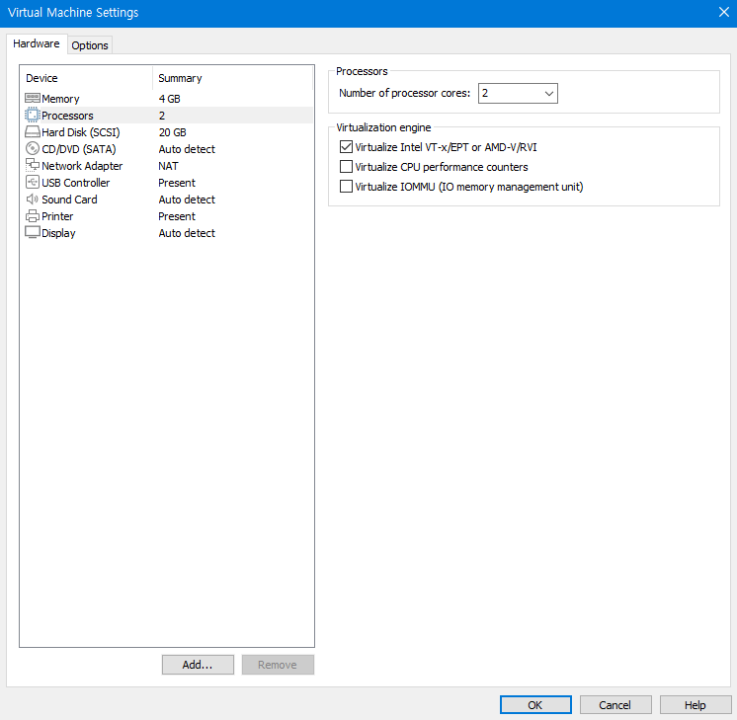

* + 흠

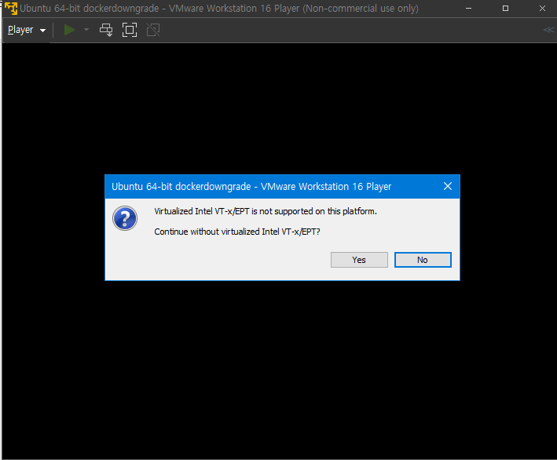

<https://askubuntu.com/questions/229181/ubuntu-in-vmware-vt-x-not-supported>

* + 내 컴의 hyper-v를 일단 꺼본다
    - 뭐 그래도 안됨.

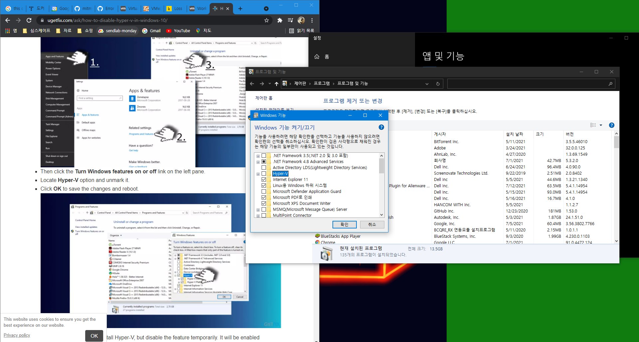

* + <https://gns3.com/community/featured/virtualized-intel-vt-x-ept-is-not-supported-on-this-platform>

wsl2를 쓰라는데.. ㅅㅂ ㅠㅠ

* 도커머신 관련 자료
  + <https://wjddyd66.github.io/docker/Docker(8)/>
  + https://engineer-mole.tistory.com/177
  + <https://sudarlife.tistory.com/210>

2020.07.13 듀얼부팅

* 남는 컴 D드라이브 결국 조각모음 하고 듀얼부팅 설치 중
  + 내 컴의 경우 빠른 시작 켜기 목록에 없었음

<https://pcsupport.lenovo.com/bo/ko/products/laptops-and-netbooks/thinkpad-x-series-laptops/thinkpad-x1-carbon-6th-gen-type-20kh-20kg/solutions/ht509048?cid=kr%3Asem%7Cse%7Cgoogle%7C%EB%8F%99%EC%A0%81%EA%B2%80%EC%83%89%EA%B4%91%EA%B3%A0_dsa_new%7C%ED%86%B5%ED%95%A9%EC%BA%A0%ED%8E%98%EC%9D%B8_new%7C%7C%7C10528953980%7C103781024563%7Cdsa-19959388920%7Cdsa%7Cmixed%7C&gclid=CjwKCAjw87SHBhBiEiwAukSeUU5OyP3-k3tZ0cVRr8Swv8GA3nJLIz49ablVKHIexyDHv3ool748gBoCoLAQAvD_BwE>

<https://symin.tistory.com/215>

<https://neoprogrammer.tistory.com/6>

<https://m.blog.naver.com/PostView.naver?isHttpsRedirect=true&blogId=mind75952&logNo=220755587962>

병신같이 USB에 iso 넣어놓고 rufus 돌리지 말 것.

* + <https://dohunkim.tistory.com/10>
  + Security boot 끄고 F12 여러 번 눌러서 Legacy Boot로 진입하여 USB Boot
  + <https://webnautes.tistory.com/1198>
  + <https://lsjsj92.tistory.com/373>
  + <https://luckyyowu.tistory.com/326> 부트로더 위치 관련. 아 ㅅㅂ ㅠㅠ
  + <https://jimnong.tistory.com/676> 여기도 부트로더 이야기가 있음
  + <https://quarker.tistory.com/22>
  + <https://www.crocus.co.kr/1593> 부트로더 자동 수정
  + <https://infondgndg91.blogspot.com/2016/08/efi-10-1604.html> 나랑 가장 유사한듯
  + <https://jimnong.tistory.com/676> 최종적으로 이대로 했음.
    - 나는 C드라이브가 GPT 방식 SSD, D드라이브가 MBR 방식 HDD
    - MBR 방식 파티션 분할 하고, USB도 MBR 방식으로 만들어놨음
    - Bios Setting 들어가서 USB 부팅을 우선순위로 올려두었음
    - 이렇게 하고 재부팅하니 바로 GRUB?이 뜬 것 같은데.. 몇 초 후 넘어가서 잘 못봤음
    - 루트 설치는 D드라이브에 하고, efi 쪽에 부트로더 설치
    - 돌아가려나…
* 도커머신 관련 자료 되게 좋다.
  + <https://engineer-mole.tistory.com/177>
  + https://engineer-mole.tistory.com/178
  + <https://engineer-mole.tistory.com/186>
* 그냥 도커도 최신 버전으로 하고 그냥 설치
* 듀얼부팅 리눅스 설치 후 재설정
  + 도커 최신 버전 설치

<https://blog.cosmosfarm.com/archives/248/%EC%9A%B0%EB%B6%84%ED%88%AC-18-04-%EB%8F%84%EC%BB%A4-docker-%EC%84%A4%EC%B9%98-%EB%B0%A9%EB%B2%95/> 대로 진행

* + 그룹추가

Sudo groupadd docker

<https://github.com/moby/moby/pull/21032>

sudo usermod -aG docker $USER

<https://dhananjay4058.medium.com/what-does-sudo-usermod-a-g-group-user-do-on-linux-b1ab7ffbba9c>

<https://gntpapa.tistory.com/entry/8-docker-%EC%9D%BC%EB%B0%98-%EC%82%AC%EC%9A%A9%EC%9E%90%EA%B0%80-docker-%EC%8B%A4%ED%96%89-%EB%B0%A9%EB%B2%95>

sudo usermod -aG docker $USER

확인 cat /etc/group

* + Sudo apt install git

git clone <https://github.com/mitmedialab/Basic.git>

* + sudo apt install docker-compose
  + base=https://github.com/docker/machine/releases/download/v0.16.0 \

&& curl -L $base/docker-machine-$(uname -s)-$(uname -m) >/tmp/docker-machine \

&& sudo mv /tmp/docker-machine /usr/local/bin/docker-machine \

&& chmod +x /usr/local/bin/docker-machine

* + gianthips@gianthips-Inspiron-15-7000-Gaming:~/Basic$ ls AgentBased_Simulator

docker-geth-network-master  Figures  LICENSE  PythonInterface  README.md

* + gianthips@gianthips-Inspiron-15-7000-Gaming:~/Basic$ cd docker-geth-network-master/
  + gianthips@gianthips-Inspiron-15-7000-Gaming:~/Basic/docker-geth-network-master$ ls

activate-mining.sh             docker-compose.yml     files                  README.md clean-docker.sh                docker-compose.yml.bk  LICENSE docker-compose-standalone.yml  eth-netstats           monitored-geth-client

* + gianthips@gianthips-Inspiron-15-7000-Gaming:~/Basic/docker-geth-network-master$ docker-compose up
  + ERROR: Couldn't connect to Docker daemon - you might need to run `docker-machine start default`.
  + sudo apt install virtualbox

docker-machine create --driver virtualbox default

* + 쫙쫙 잘 돌아가네..
* Waiting for machine to be running, this may take a few minutes...
* Detecting operating system of created instance...
* Waiting for SSH to be available...
* Detecting the provisioner...
* Provisioning with boot2docker...
* Copying certs to the local machine directory...
* Copying certs to the remote machine...
* Setting Docker configuration on the remote daemon...
* Checking connection to Docker...
* Docker is up and running!
* To see how to connect your Docker Client to the Docker Engine running on this virtual machine, run: docker-machine env default
  + docker-machine ip default

192.168.99.100

* + Sudo apt install net-tools
  + **Reboot**
  + Docker-machine start default
  + Docker-compose up
    - 리붓 전에는 안 돌았는데
    - 지금은 돌기 시작. 일단 보자.
    - 일전의 오류 발생
  + Dockerfile 수정
  + Docker-compose up
    - 잘 돌아감. 확인하고 ctrl c 하여 종료
  + Docker-compose up -d
    - 백그라운드에서 돌아가도록
  + Docker-compose scale eth=3
* docker exec -it docker-geth-network-master_eth_1 geth attach ipc://root/.ethereum/devchain/geth.ipc
* 깔 것 다 깔았다. 도커머신으로 프로비져닝해서 돌려보기
  + 우선 도커머신 재시작 및 도커 컨테이너 삭제

https://github.com/docker/toolbox/issues/453

<https://seulcode.tistory.com/241>

<https://brunch.co.kr/@hopeless/10>

<https://snowdeer.github.io/docker/2018/02/12/docker-stop-and-remove-all-containers/>

* + - ~~Docker stop $(docker ps -a -q) 로컬이라 필요 없는듯~~
    - ~~Docker rm $(docker ps -a -q) 로컬이라 필요 없는듯~~
    - Docker-machine rm default
  + Docker-machine create –driver virtualbox default
    - 이거하려면 virtualbox는 깔아둬야 함. Apt-get 이었나
  + Docker-machine ls

activate되어있지 않음을 확인 가능

* + <https://sudarlife.tistory.com/210>

~$ docker-machine env default

~$ eval $(docker-machine env default)

이제 activate에 원래 – 되어있다가 * 됨

* + Virtualbox

명령쳐보면 virtualbox 실행화면 뜨고 default머신 나오는거 볼 수 있음

* + 이제 docker-compose 실행환경인듯.
    - 근데 docker-compose up 하면 자꾸 이렇게 뜨네..
    - gianthips@gianthips-Inspiron-15-7000-Gaming:~/Basic/docker-geth-network-master$ docker-compose up
    - ERROR: SSL error: HTTPSConnectionPool(host='192.168.99.100', port=2376): Max retries exceeded with url: /v1.22/info (Caused by SSLError(SSLError(1, u'[SSL: TLSV1_ALERT_PROTOCOL_VERSION] tlsv1 alert protocol version (_ssl.c:727)'),))
    - <https://stackoverflow.com/questions/49026722/docker-compose-up-throws-ssl-error-using-docker-machine>

여기있는대로 docker-machine regenerate-certs –clients-certs해봤는데 안됨.

* + - 리붓 했음
    - Docker-machine start
    - Docker-machine env
    - Eval $(docker-machine env)
    - 경로 이동 후 docker-compose up. 역시 같은 문제

<https://kb.vmware.com/s/article/74992>

export COMPOSE_TLS_VERSION=TLSv1_2일단 이렇게 대처

환경변수 설정을 해야할 듯 한데

이건 나중에 하자. <https://inpages.tistory.com/131>

돌아가긴 한다. Ctrl c

* + - Docker-compose up -d
    - Docker-compose scale eth=3
    - gianthips@gianthips-Inspiron-15-7000-Gaming:~/Basic/docker-geth-network-master/monitored-geth-client$ docker exec -it dockergethnetworkmaster_eth_1 geth attach ipc://root/.ethereum/devchain/geth.ipc
      * Error response from daemon: Container da161122a31042aa637eb80558296ea4c2ab32400bfcb4db31346ca63c343aa5 is restarting, wait until the container is running 흠…
    - 오 netstat까지는 뜸..

Firefox <http://$(docker-machine> ip default):3000

* + - 근데 왜 mining이 안붙지

210722_수도계정으로 docker-compose 및 attach

연욱이가 수도 계정으로 했을 때 docker-compose가 다 되고, mining까지 되는 모습을 확인함. 이를 나도 팔로우업 해봄

* docker-machine create -driver virtualbox default
* docker-machine env default
* eval $(docker-machine env default)
* docker-machine ls
  + 머신이 돌아가는 것(*) 확인
* 폴더 경로 이동하여
* sudo docker-compose up -d
* sudo docker ps 하면 컨테이너가 보임. 그러나 docker ps하면 안보임
* sudo docker-compose scale eth=3
* sudo docker ps하면 컨테이너가 보임
* sudo docker exec -it dockergethnetwork_eth_1 geth attach ipc://root/.ethereum/devchain/geth.ipc
  + 어태치가 되고
  + miner.start()하면 null이 나오고
  + web3.eth.mining을 해서 마이닝이 시작된 것인지, eth.mining을 해서 시작된 것인지 잘 모르겠음. 처음에는 eth.blockNumber를 했을 때 채굴이 안되는 모습. 그러나 곧 몇 초 후 eth.blockNumber를 했을 때 숫자가 증가하는 모습이 보임
  + exit
* sudo docker ps를 지속적으로 쳐봤을 때 각 컨테이너의 start들이 restart 되지 않고 계속 up으로 떠있는 것을 확인
* 연욱이 고생했네..
* root 계정으로 돌아가서 docker ps를 하면 내 계정에서의 sudo docker ps와 동일한 모습이 나옴
* 만약 컨테이너 속의 파일들을 보고 싶다면? sudo docker ps를 통해 나온 컨테이너 번호를 이용하여

sudo docker exec -it 컨테이너번호 /bin/bash 의 방식으로 내용물 확인

* + 이렇게 하면 docker 컨테이너의 root 계정으로 진입함 예를 들어 기존 root@gianthips-Insp.. 이런게 아니고 root@abd069d1d6ce 이쪽으로.
  + 여기서 cd .. 여러 번 쳐서 끝까지 가고 cd root을 검색해서 들어가면 폴더들 다 있음